Student’s Name
Tutor
Course title
Date
Part 1:

The major parts that occupy the center are the Neutrons and protons and the Centre is what it’s termed as the Nucleus.

- .

The existence of either excess or even less amount of neutrons and protons is what makes the center of an atom more unstable.

 | What is in your nucleus? | Capture and paste your atom | Is it stable or unstable? | What Element is it?
1 | The nucleus consist of 3 neutrons & Protons. | 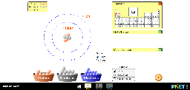 | This can be considered very stable. | The element in question is the Lithium
2 | The nucleus contains 4 major protons& its Neutrons. | 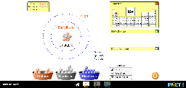 | This can be regarded as very unstable. | The element in question is the Beryllium
3 | The nucleus majorly consist of 6 protons & neutrons. | 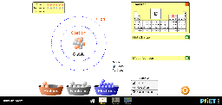 | Yes, it’s stable. | Carbon is the element of great concern.

- In the event that there exist the same amount of particularly electrons and protons, then the element is regarded to contain a more neutral atom. However, if the amount of electrons and probably the protons aren’t the same, then we will automatically have an ion.In the event that they are more protons compared to electrons, the element is considered a positive ion.
  - It dictates that the both the amount of electrons and protons needs to be the same
  - There has to be more Protons as compared to the electrons.
  - The protons must be less as compared to the electrons which should have to be more.
  - One of the essential tools was the net charge tool which played a critical part in deciding the particular charge that an atom had.

 | What is in your  Atom or Ion?  (Stable only) | Capture and paste your atom or Ion | What is  The charge? | Is it a neutral atom, positive Ion,  Or negative Ion? explain why
 | Protons (5)  electrons (5)  Neutrons(3) | 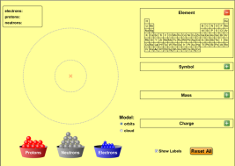  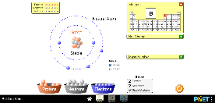 | It’s a neutral charge. | It’s a neutral a tom due to the fact that it has an equal amount of electrons and protons
 | Electrons (5) Neutrons (3).  Protons (3) | 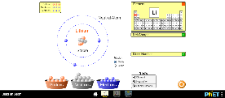 | It’s a negative charge. | It’s Negative due to the fact that protons and less than the electrons
 | Protons (7)  Electrons (6)  Neutrons (7) | 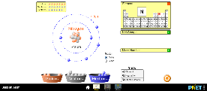 | It’s positive charge. | It’s positive due to the fact that the electrons are less than the protons

- The amount of neutrons and protons constitute to the mass of the atom. In order to test this, I will focus on trying more different atoms as guided by my set rules as I observe if the atom which contains an a mount neutrons and a reasonable amount of protons ,has the same quantity of mass
Part 2:

- Quantity of existing Protons.

example | Atom or Ion has | What Element is it?
 | Protons (6)  Electrons (6)  Neutrons(6) | This is a carbon element.
 | Neutrons(6)  Protons (7)  Electrons (6) | This is a nitrogen element.
 | Neutrons (7)  Protons (6)  Electrons(7) | This is a carbon element.

It basically enlightens us mainly on the atomic number of a given atom, mass number of both protons and neutrons and the charge of an atom at large.

Through the mass number, you can determine a distinct amount of neutrons and protons. Also, if it is a neutral atom, electrons and protons will have the same amount.

Make the change: | What changes also? Element name, charge, mass?
Add a when a proton is added. | Name of the Element, the charge changes from neutral to positive, and increased mass by 1.
RRem when a neutron is removed | The Element becomes unstable, the charge remains neutral, but the mass decreases by 1.
Remove an electron | The Element is stable, the charge changes to positive, and the mass remains.
Add an electron | The Element is stable, the charge changes to negative and the mass remains.

Part 3:

  - In my case, there was no any rule that I happened to have changed, because to find the element, I basically used the number of protons which I later on used the neutrons number to determine its neutrality.

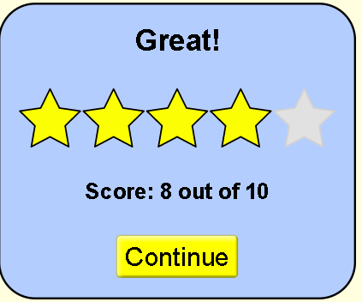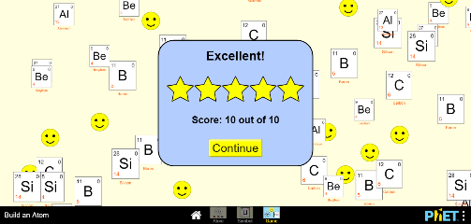

  - This particular level was relatively challenging due to the fact that I did not have the diagram for some questions that messed me up. It was therefore necessary to keep the same approach that was previously used.

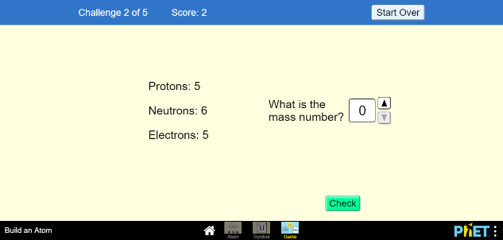

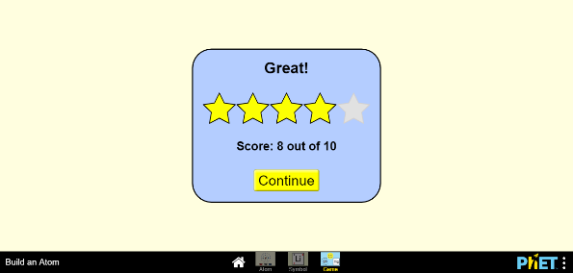

  - I upheld a similar strategy and rules; hence the level was no more complex than the last.

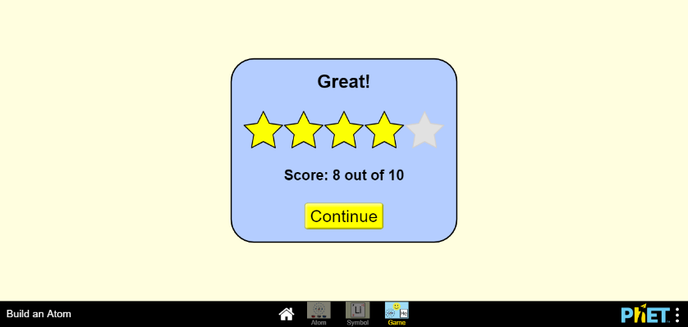

  - I had experience from the previous levels, which simplified this level.

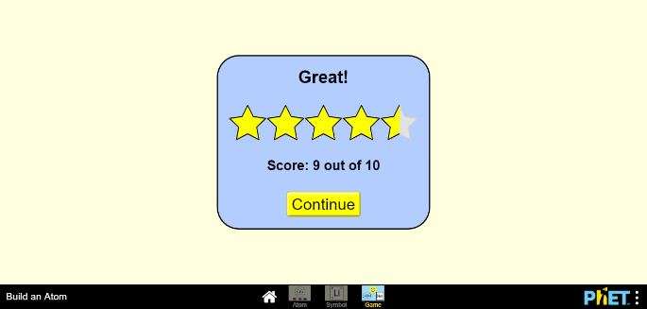

Final Score:

